**Cooking Mama Dodge** – the food has rebelled, try to avoid them all!

**Gameplay Overview**

Description: Use the arrow keys to move Mama around the screen and avoid the food flying at her. The foods flying at her will change and the speed at which they fly towards her will increase. Certain items (such as a fork or knife) will serve as powerups, some items will hurt her and cause her to lose a life. The game is inspired by Neopets’s Ice Cream Machine Game.

Win: Try to get to the end of the game by beating all the levels

Lose: Mama loses all of her lives

Cheat: A golden heart will make her invincible to all the food flying at her

**Controls**

Arrow keys: move the player around

Start: starting the game, pause game 🡪 brings you to a menu

A: in pause menu, allows you to resume game

B: in pause menu, allows you to return to main screen

**Audio**

* Menu music: something light and happy
* Game music: similar to the menu music but a bit faster
* Pause music: menu music
* Hit by a dish: a soft “pew” sound (getting hit sound)
* Losing entire game plays sad trumpet

**Gameplay**

Use arrow keys to move player to dodge food

**Illustrations**

These are the original screens that show different levels:

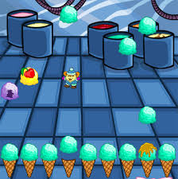 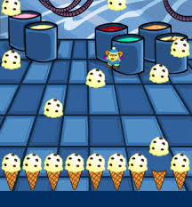 

Instead of the ice cream at the bottom of the screen I want to use the sprites in the sheet below (not all of them, maybe 8 levels?):

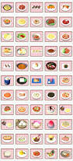

Player sprite and background:

 